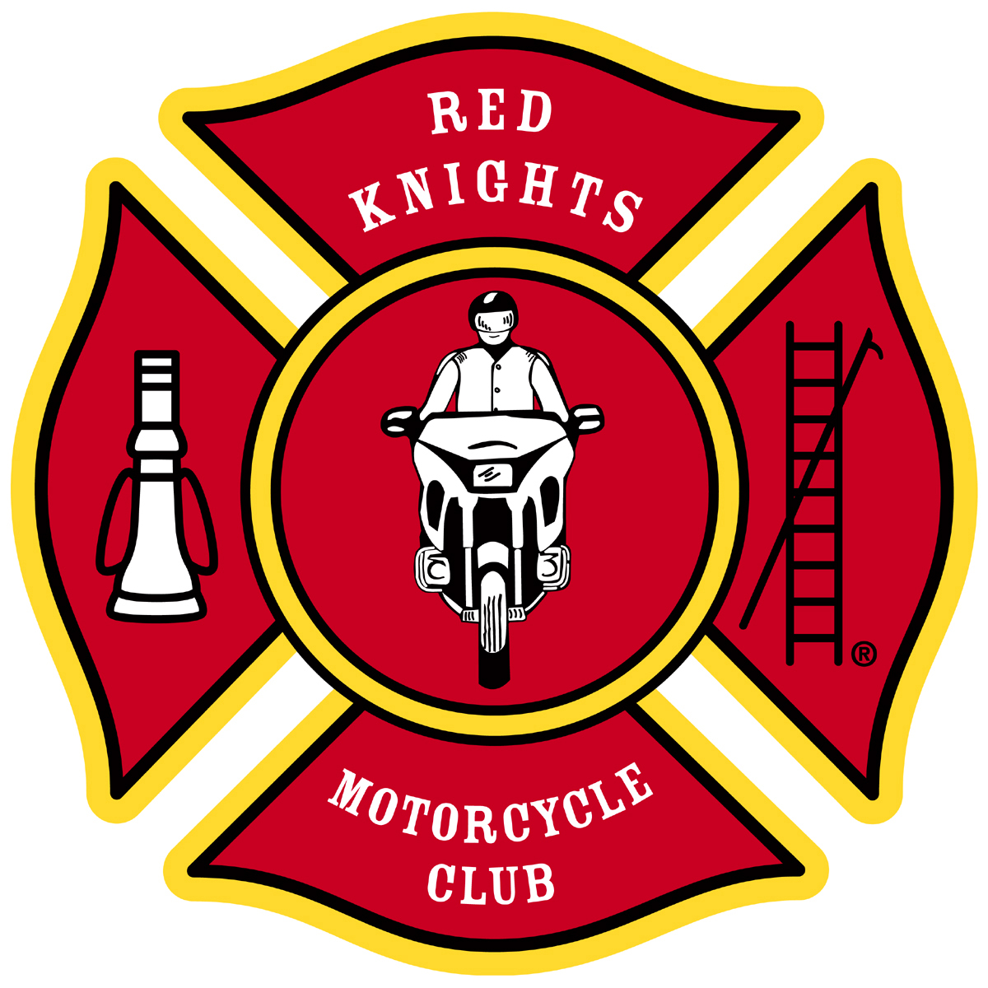
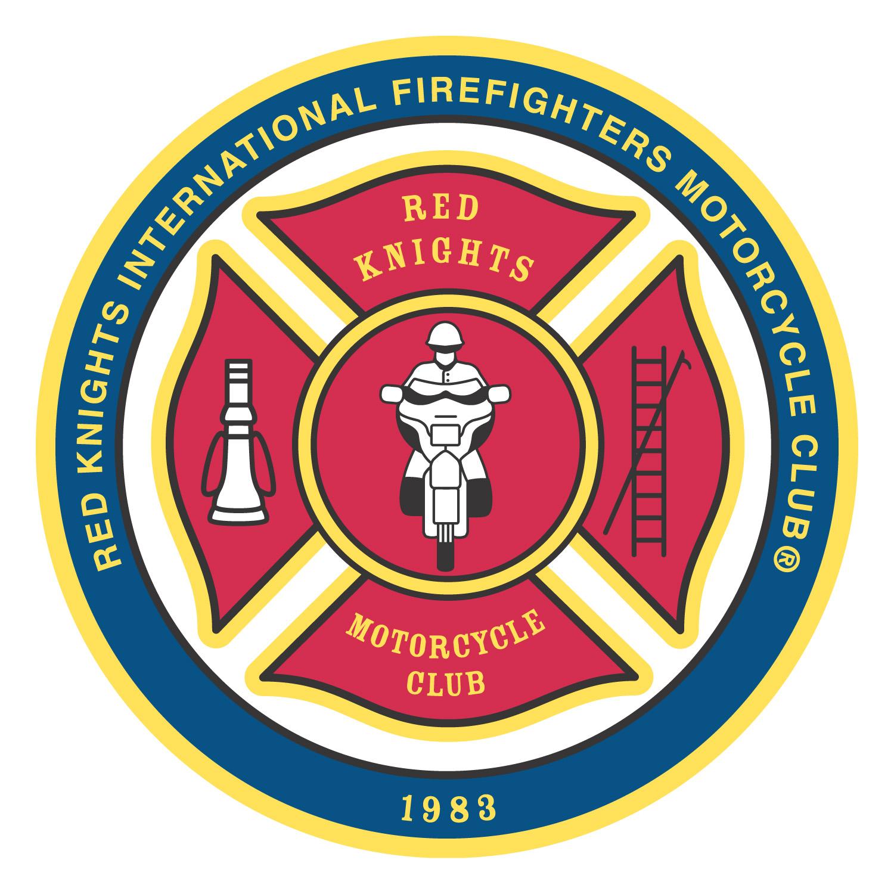
®
Red Knights International Firefighters Motorcycle Club® Inc.
Office of the Region 2 Director
Leo J. Patry
region2@redknightsmc.com

To the membership of the Red Knights International Firefighters Motorcycle Club.

I would like to take this opportunity to thank you for your support and trust during my time of holding various positions over the last 32 years as an international officer.

Like all things in life there is a beginning and an ending.

So as of this date of September 9, 2023, due to declining health issues which are impeding my ability to fully perform the duties and responsibilities as a regional director I must step back and resign my position as a regional director.

Sincerely yours

Leo Patry

